Dear Brothers and Sisters in Christ,
We thank the Lord for His abundant blessings in 2015, and thank you for your participation in doing the work of the Lord here through St. Paul’s’ ministries of Worship, Teaching, Caring and Serving.
Ministry and Financial reports are available on the website at www.StPaulsDec.com on the Links tab and in the Church Office as they become available. Highlights are captured below.
Worship
Weekend worship services and special Lent/Holy Week/Easter and Christmas Eve/Christmas Day services were held in Spirit and Truth worshiping the Lord with gladness and thanksgiving for His many blessings during 2015. Several opportunities for combined worship as one congregation were offered followed by fellowship meals.
Pastoral Changes
Pastor Chris Brynestad accepted a call to King of Kings Lutheran Church, Round Rock, TX in May. Pastor Eddie Scheler accepted a call to Ascension Lutheran Church, Cleburne, TX in November. These moves get them both nearer to their families. We miss them and pray God’s mercy in their new ministries. To quote one of our members, John Mann,
“God has a plan for St. Paul’s Lutheran Church!!! God has a very holy and fulfilling purpose for each and every member and visitor who comes to us. In order to discern where God is leading, therefore, this time of transition will be a journey of faithfulness that hearkens to the prophet’s call, ‘Return to the Lord your God.’”
Interim Plans
Our Elders, Worship Coordinators and Pastoral Assistants have our worship services well planned and staffed. Pastor David Doroh, retired, Our Redeemer, Florence, is our main interim guest preacher, and Pastor John Ninke, Christ Our Redeemer, Hartselle, is nearby for emergencies. To accommodate the guest preachers and to maintain a pastor in each service, our worship service opportunities have been streamlined during the interim to offer Traditional worship at 8:15 am (Communion on 1st & 3rd Sundays) and CrossLife Praise and Worship at 10:45 am (Communion on 2nd & 4th Sundays).
A Call Committee has been appointed and is in the process of preparing a congregational self-study. This will aid in selecting candidates to present to the congregation for consideration for the next pastor that we know that God has already selected by name for us. The Call Process is simply God’s plan for us to find ourselves and better define our goals and mission as a congregation as we are led to the man who will lead us as our next shepherd. Congregational president, Dave Burrell, encourages us to approach the call process confidently and deliberately, while taking adequate time for prayer, study, introspection and planning. We are to keep each of the call committee members in our prayers, encourage them in their work, and to communicate any suggestions or concerns we may have.
Craig Baker (Chairman) | Cy3a@earthlink.net | 256-686-2134
Joy Dixon | joy.dixon@dcs.edu | 256-303-7589
Mike McRae | michael@mcrae.net | 256-341-0092
Jeff Morgan | tigertron@gmail.com | 256-227-9954
Ron Neuendorf | ronneuendorf@bellsouth.net | 256-355-6550
Rhonda Reece | rlsreece@aol.com | 256-350-4459
Laura Tyler | l.miatyler@gmail.com | 903-767-6141

Bible Study
Sunday morning Power Hour and Wednesday evening FaithLinks with classes for all ages and mid-week and home group Bible studies for adults met faithfully throughout the year providing study of God’s Word and training in what the Lord has instructed for us in His Word.
Ministry
The Lord has blessed the many ministries by St. Paul’s where we gladly serve Him while serving others. We are especially encouraged at this time to seek out ministry in which to use our spiritual gifts that God has given us. The enclosed flyer describes in detail the Worship, Teaching, Caring, Serving and Fellowship ministries available through St. Paul’s. If you are unsure of your spiritual gifts, please check with the Church Office for some assistance.
Congregation Participation
Researchers for Christianity Today, Pew Research, and Gallup Polling to name a few have seen a change in trends in local congregations faster than any time in our lifetime. One of the most disheartening changes is the declining attendance in a majority of churches. Our attendance at St. Paul’s has seen this decline as well:
Average Worship Attendance Average in Bible Study Average in Ministry
2010 | 392 |  | 2010 | 190 |  | 2010 | 263
2011 | 366 |  | 2011 | 192 |  | 2011 | 259
2012 | 375 |  | 2012 | 193 |  | 2012 | 247
2013 | 357 |  | 2013 | 173 |  | 2013 | 286
2014 | 328 |  | 2014 | 202 |  | 2014 | 283
2015 | 304 |  | 2015 | 170 |  | 2015 | 277

While the culture and our environment may change, the changeless Word of God stands, and we at St. Paul’s endeavor to worship and serve Him regularly to His glory.
Financial Summary
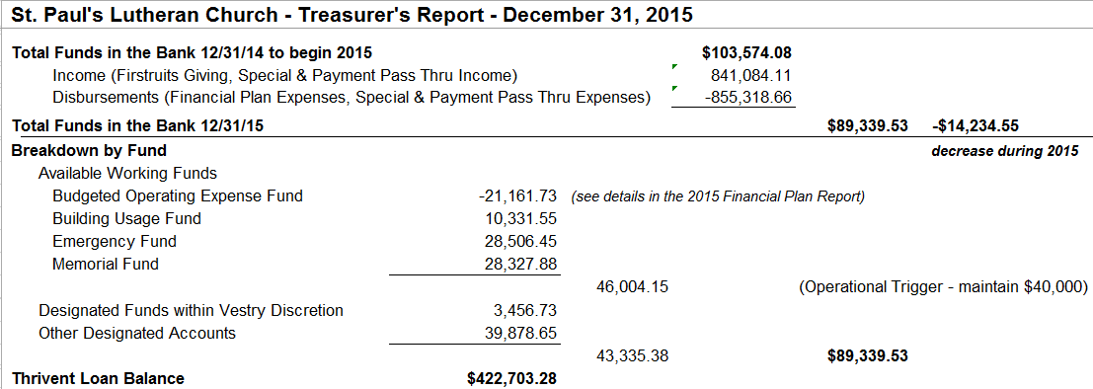
During this interim especially it is vital for us to pray for the congregation and to actively take part in worship, Bible study and ministry activities. To fund these activities our gifts to the work of the Lord continue to ensure that St. Paul’s is connecting people to Jesus and growing His kingdom. Our 2015 Finances are summarized as follows:
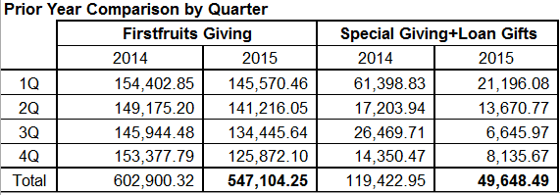
St. Paul’s Lutheran Church – Financial Secretary Report – December 31, 2015
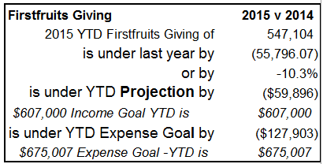
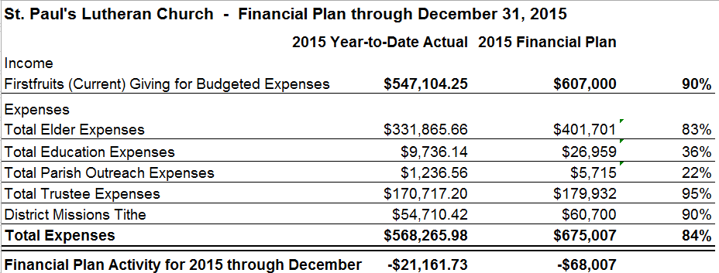
On December 30, 2015 our building loan was refinanced with Thrivent Financial for a term of 7 years at a 3.5% interest rate with the goal of paying the loan off completely in less than 5 years with the help of additional gifts to the principle.

The 2016 Financial Plan is projected at $594,994 in Total Expenses and includes the salary of one Pastor and a Children’s Ministry Director. We pray God’s blessings as we undertake the planned ministries in the year ahead.
In His Service,
St. Paul’s Vestry Team

